April 21, 2021

Index to the Kamenka Parish Records

Consisting of the villages: Hildmann, Husaren, Kamenka, and Pfeifer

- Please read the “INTRODUCTION” before viewing the Index to the Parish records. It contains valuable information to simplify your search of the Latin birth, marriage and death records for Kamenka Parish.

- If you require assistance to understand the actual Kamenka Parish Latin birth, marriage or death images, please go to “ASSISTANCE WITH READING LATIN BIRTH, MARRIAGE & DEATH RECORDS.”

- Additional information about the formation of Kamenka Parish (and other parishes) is included in “MORE USEFUL INFORMATION.”

INTRODUCTION

Format of the Kamenka Parish Index
a) The "Kamenka Index" is comprised of three separate worksheets.
b) Each worksheet represents an event: Birth, Marriage, or Death.
c) Each event, i.e., birth, marriage, or death is then recorded by the year that the event
took place.
d) Following each year, the “Individual Surnames" are alphabetized with the “Given
Names” noted in the column to the right of the surname.

e) To view the image containing the information on the individual being researched –
click on the Image Number (e.g., 1838B_09 - in the column to the left of each entry).
This is the link that will take you to the particular page of interest.

f) You will be directed to the page in the registry where the individual’s surname, given
name, date of event and other pertinent information are recorded.

Extracting versus Translating
The attempt is to present information in the “Kamenka Index” exactly as it is on the recorded event. Information is “extracted” rather than “translated.” This may provide challenges for the researcher.

Extracting Spellings

In some cases if a surname was “misspelled” by the priest/scribe logging it down, the correct spelling is added in brackets, e.g., The surname on the record was “Gedde” but the accurate spelling was “Gette,” it was noted as Gedde [Gette].
Extracting Unreadable/Unable to Understand Texts

If information was unreadable or not understandable, it was noted with a "?" after the entry, e.g., gledden? or 05? (for a date)
Extracting Special Characters and Abbreviations
“Special German characters” are either extracted “as is” or altered.

ä (umlaut -a) e.g., Mäßler, Schäfer, Rollhäuserin
ö (umlaut-o) e.g., Köhler, Römisch, Rötarmel, Göbel
ü (umlaut-u) e.g, Güttlein, Münnich, Müllerin

The above special German sounds are extracted exactly as shown.

The alternate form of lower-case “s” is an “f-like symbol.” It is extracted as “s.”
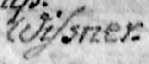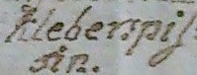
e.g., Wissner Wißner e.g., Kleberspissin Kleberspißen
Eszet - ß - In German, the ß character is called eszet. It's used in “Straße,” the word for street. It's often translated as “ss.” It is extracted as “ss.”

There are other letter combinations: ch, sch, ck, and tz, ph, th and dt, as illustrated below that are extracted as shown in the first column on the left, whenever possible.

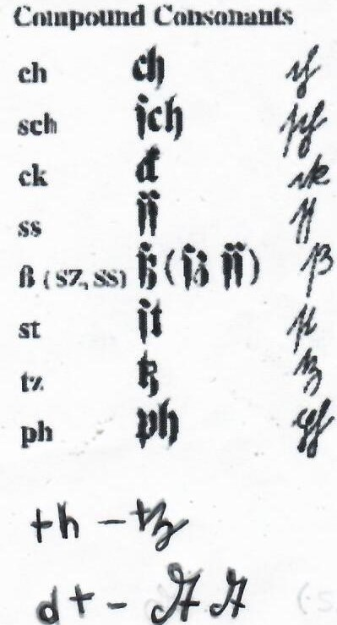

Overline - In German an “overline” (a line over the letter) is occasionally used to indicate a pair of letters which cannot both be fitted into the available space.

The “overline” character below is extracted as a double letter. In this example, mm.”
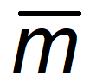

Tilde ( ~) was originally written over an omitted letter or several letters as an abbreviation by scribes. It was a contraction mark (e.g., don’t, I’ll). The “tilde” mark could denote the omission of one letter or several letters.
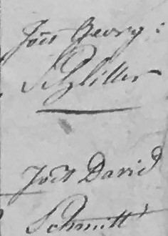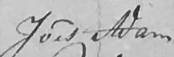
In this case, the“tilde” character is disregarded. The extraction for the above is “Joes.”

A colon was also written to save labour, ink, space and vellum after a name, date, etc.
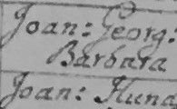 e.g. Joan: = Joannes
The colon above is extracted as Joann: (a bold colon)
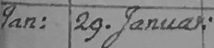

g was used as a shortened form of “ous” “us” “ius.”
e.g., 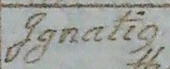 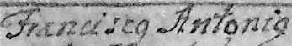
The g-like character is extracted as “g” (a small “italicized” g that represents the numerous endings shown above.

“Gna” or “Idem” was used to denote “ditto” for names and numbers.
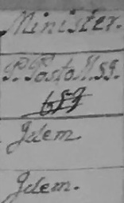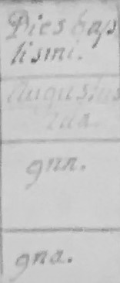
The actual name or number was extracted – not the “ditto.”

At the end of some women’s surnames an “in” denotes that the person was a female. 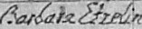
The “in” ending above is extracted as it is shown.

Surname Spellings - Explanations
Many given and surnames were misspelled by the priests/scribes. These were legal records of birth, marriage and death so they are presented as they were recorded, e.g.,
Vilhelmi Gitlein remains misspelled in the Kamenka Parish Index (rather than correcting it to Wilhelm Guettlein).

As well, over the years, many surnames changed, for numerous reasons, which will be noted below, e.g., the surname is Mahler. On his "Passport" into the USA, it is spelled Mehler and in the "Russian part" of the passport it is Meler. On some of the census (in Russian), it is spelled Meler, or Mehler (census taken by a Russian in Russian and translated to English years later). On the "Original Settlers List, " i.e, the 1767 Census, it is spelled Miller (taken by a Russian in Russia and translated to English). In the German Archives in Germany, the family surname is “Miller.” So, Mahler Mehler, Meler or Miller are all versions of the original German name of Miller.
Most of the Volga Germans were illiterate and their names were spelled out by passport agents, and Russian census takers. As well, initially, German priests (i.e., Jesuits) recorded the births, marriages and deaths in Latin but later Polish priests (who did not speak German) were brought into the Volga area and recorded the German names in Latin. Scribes also made copies of the parish records. The above are only some of the reasons for the many spellings of not only the colonists’ surnames, but also their given names and even spelling errors when naming the villages.
It is of the utmost importance that a researcher has an “open mind” when looking through the Index for family surnames. A slight to major misspelling is not uncommon and is expected. In fact, many given and surnames are spelled phonetically.

In summary, the entries in the Kamenka Parish Index are not “translated.” The entries are "extracted." The consideration, analysis, and final assessment of the validity of surnames offered is left to the researcher.

Given Name Spellings

Below are a sample of Latin names found in the Kamenka Parish records that do not closely resemble their English equivalents. A more comprehensive list can be found at:

https://en.wiktionary.org/wiki/Appendix:Latin_forms_of_English_given_names

Latin English

Aloysius Aloys
Andreas Andrew or Andre
Anna Ann, Anne or Hannah
Carolus Charles, Carl
Conrad Conradus, Kurt
Constantia Constance
Christophorus Christopher
Cunegundis Cunegunda
Gasparus Jasper, Casper
Godefridus Gottfried
Gulielmus,Guglielmus William, Wilhelm
Johanna, Joanna Joan, Jane, Janet
Joannes, Johannes John, Jack, Hans
Hieronymus Jerome
Jacoba Jacqueline, Jackie
Jacobus Jacob, James, Jack
Margarita Margaret
Philippus Philip, Phillip
Rubina Ruby
Theodoricus Derek, Dietrich
Valentinus Valentine
Willelmus, Uilemus William, Wilhelm

ASSISTANCE WITH READING LATIN BIRTH, MARRIAGE & DEATH RECORDS

Kamenka Parish Records – Where to Look for the Information

The format of the Kamenka Parish Register changed in the years 1810 and 1835.

The following are samples – Up to 1809, 1810 to 1834, and 1835 and on, to simplify reading these records.

Up to 1809 – Birth/Baptism, Marriage and Death Records

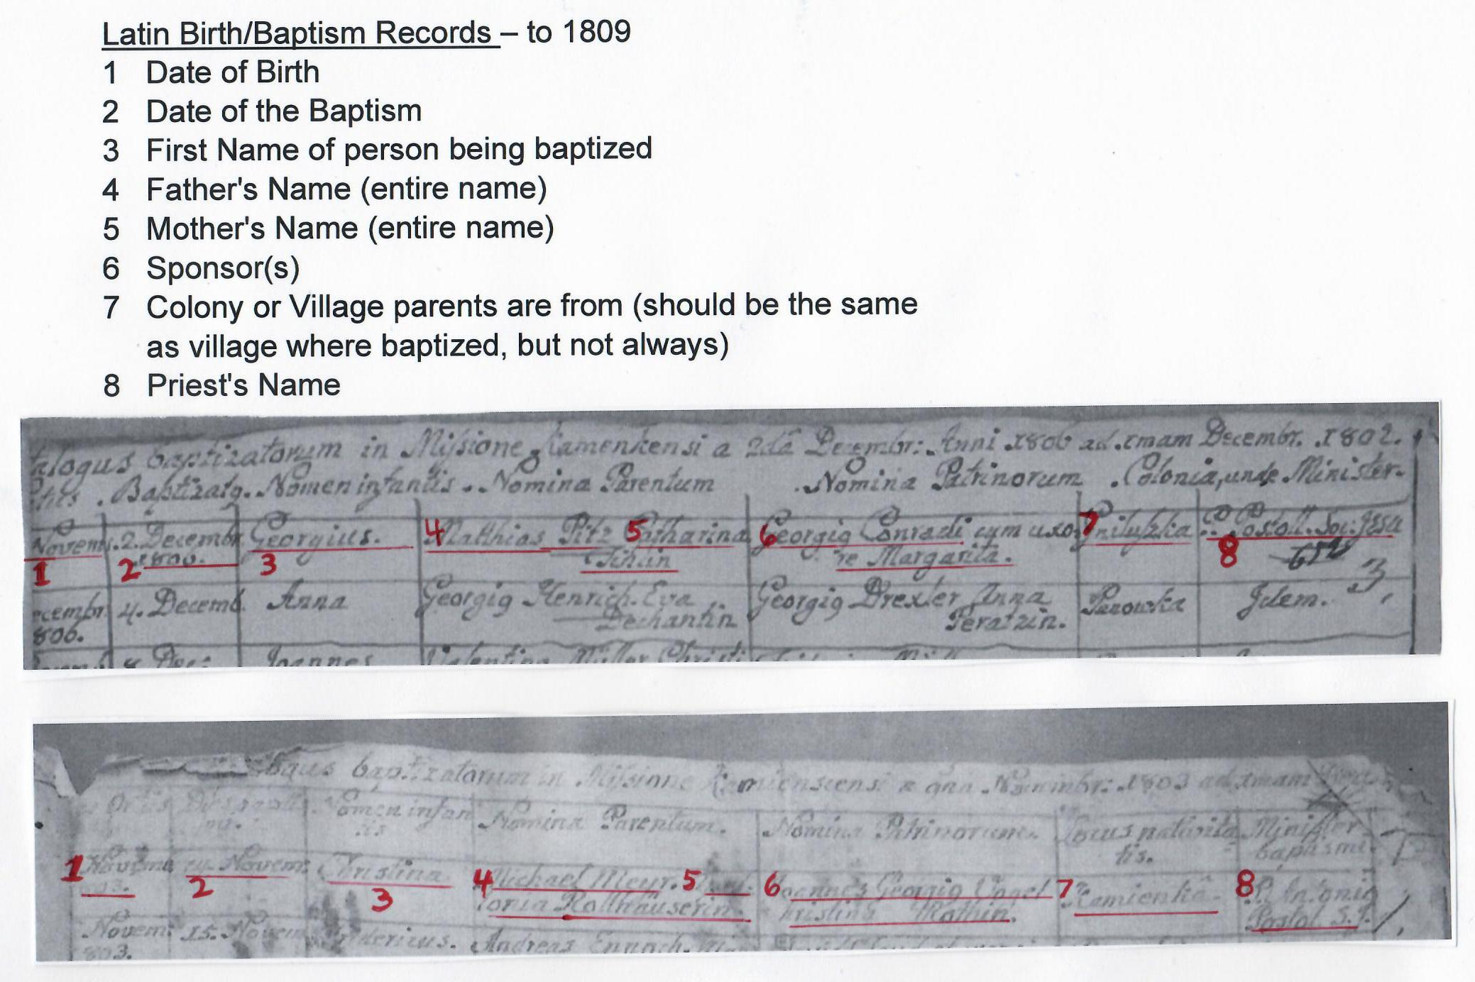
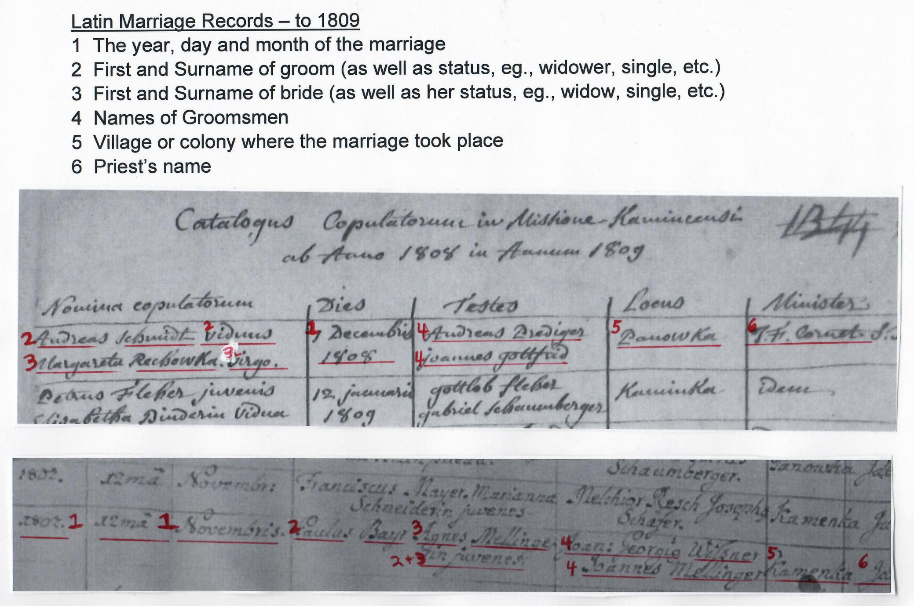

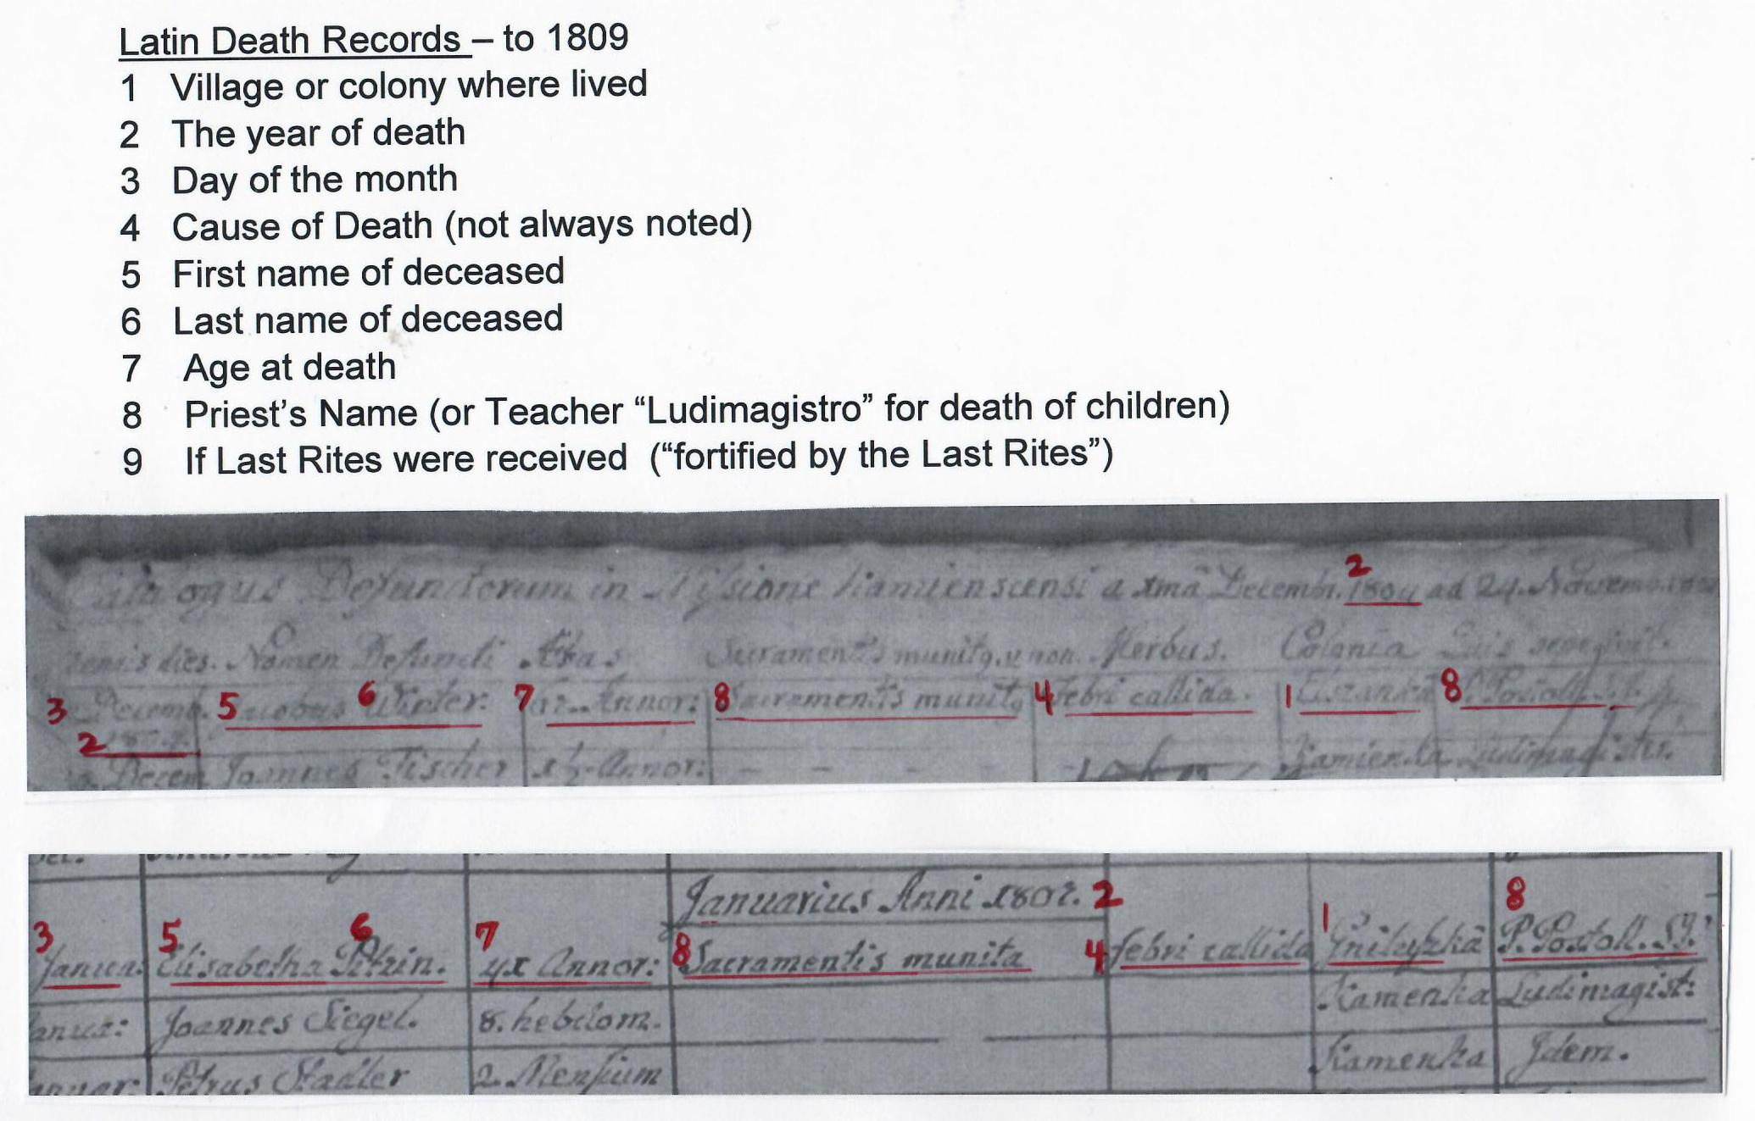
1810 to 1835 – Birth/Baptism, Marriage and Death Records
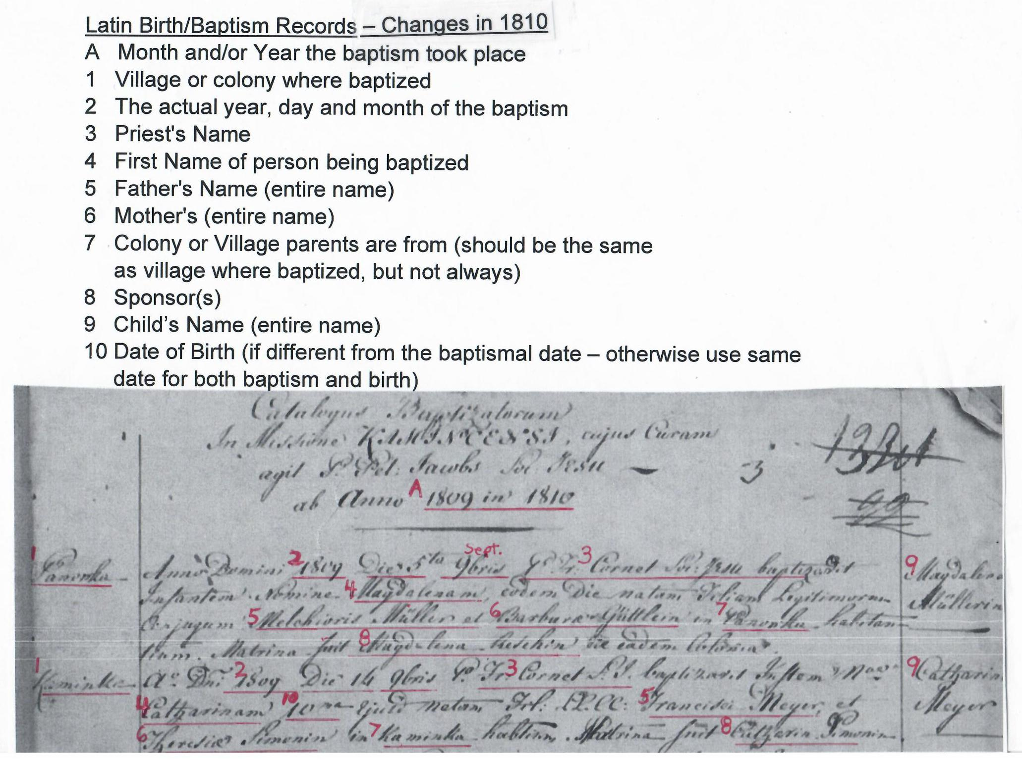

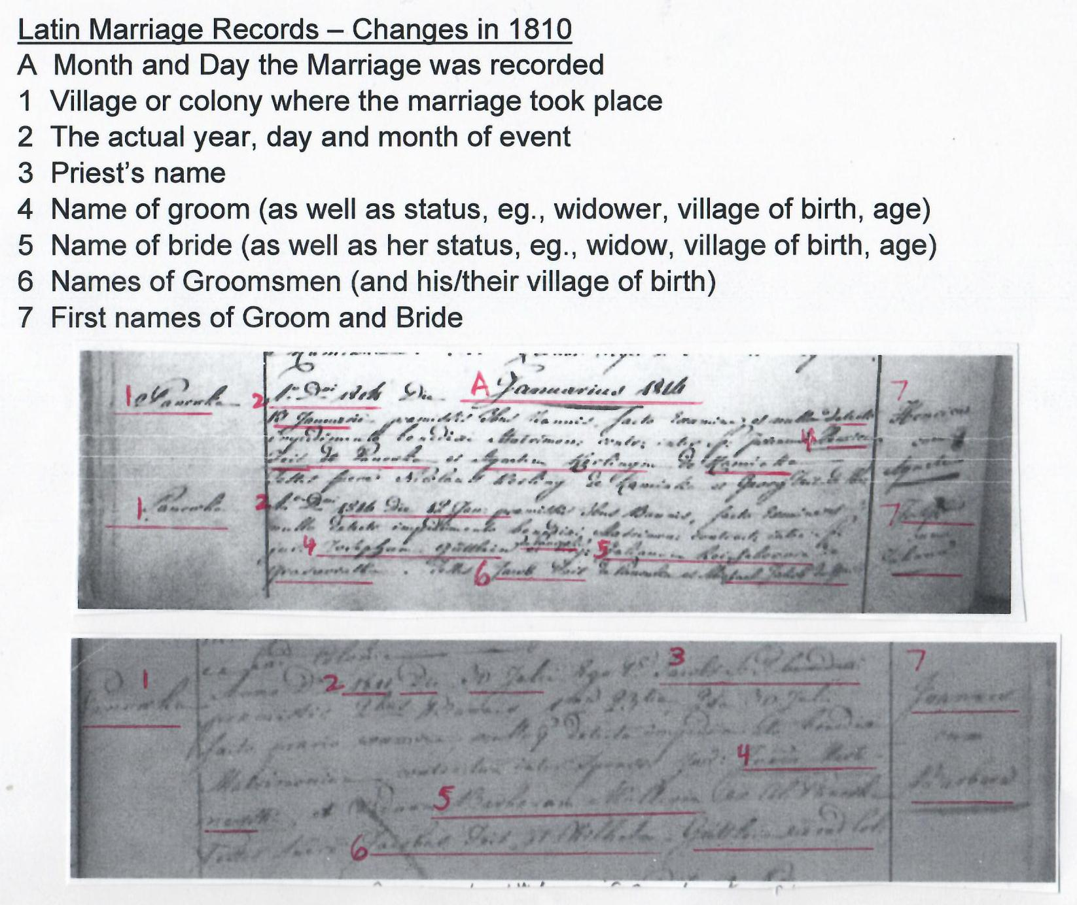
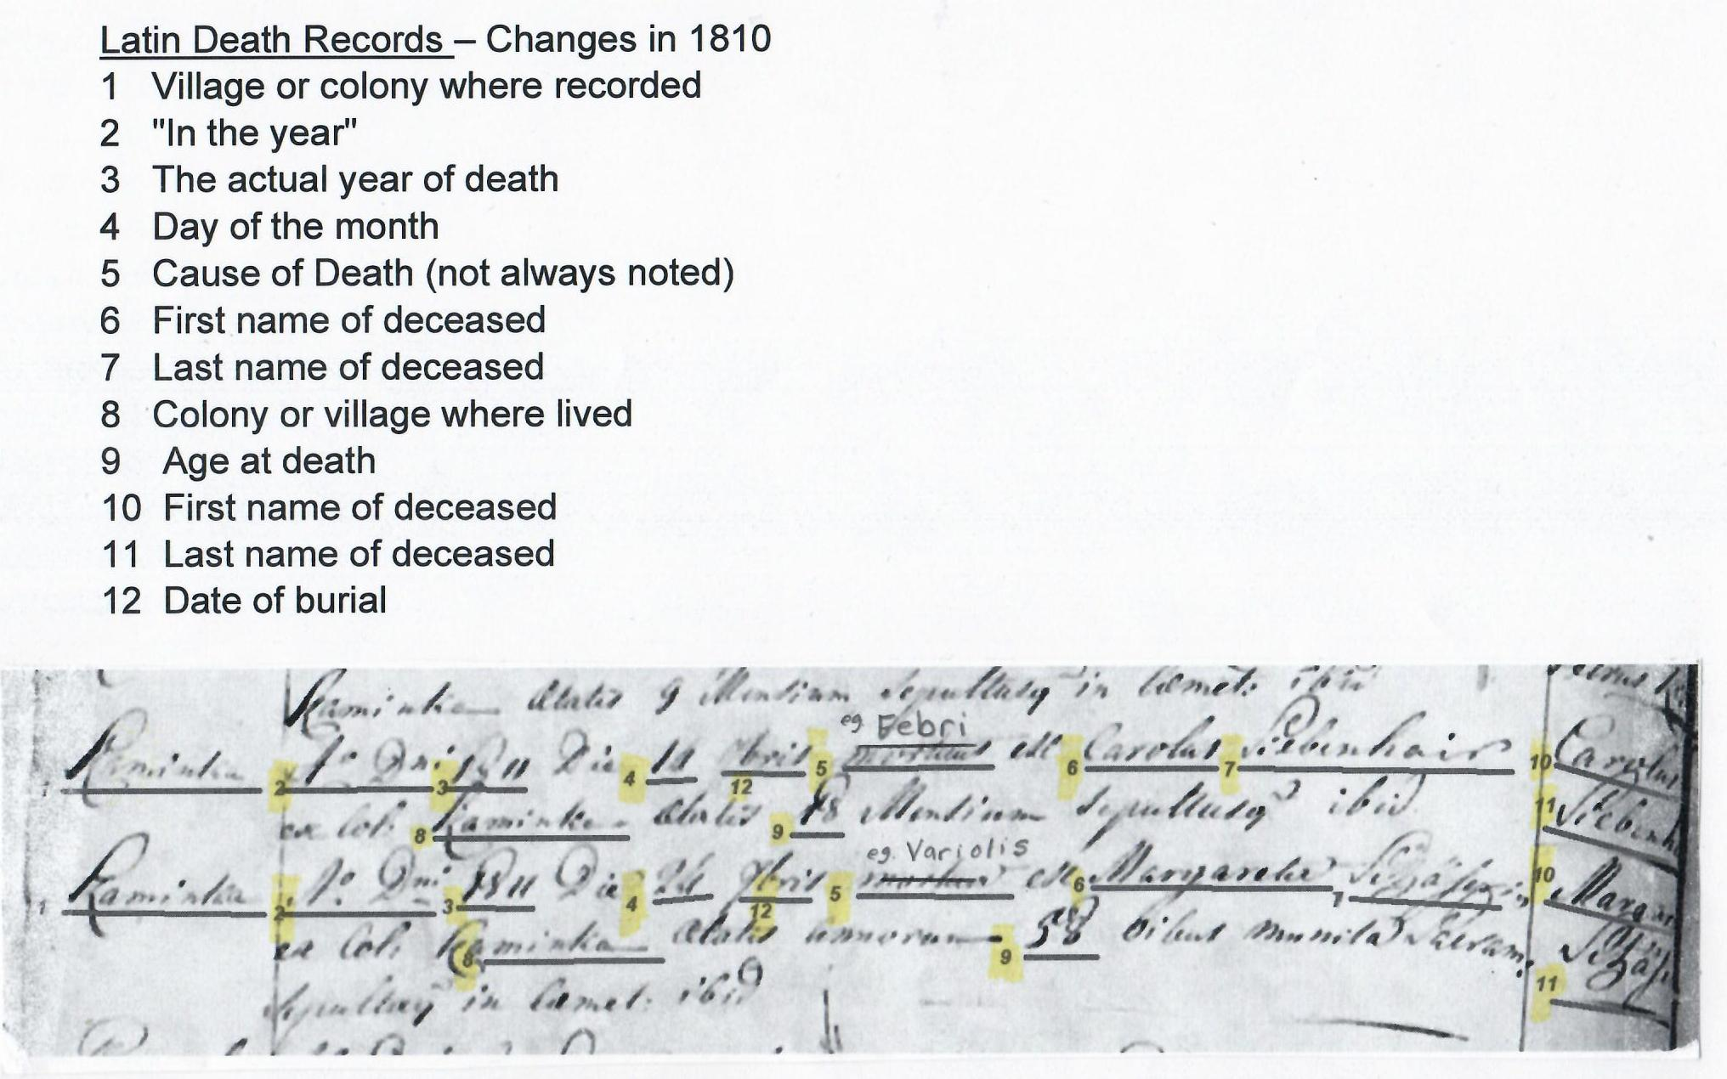

1835 and on – Birth/Baptism, Marriage and Death Records

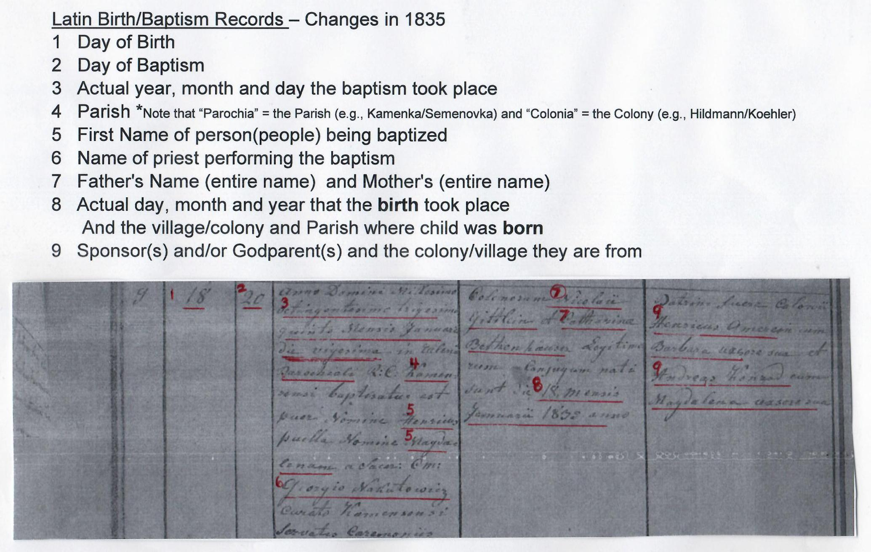
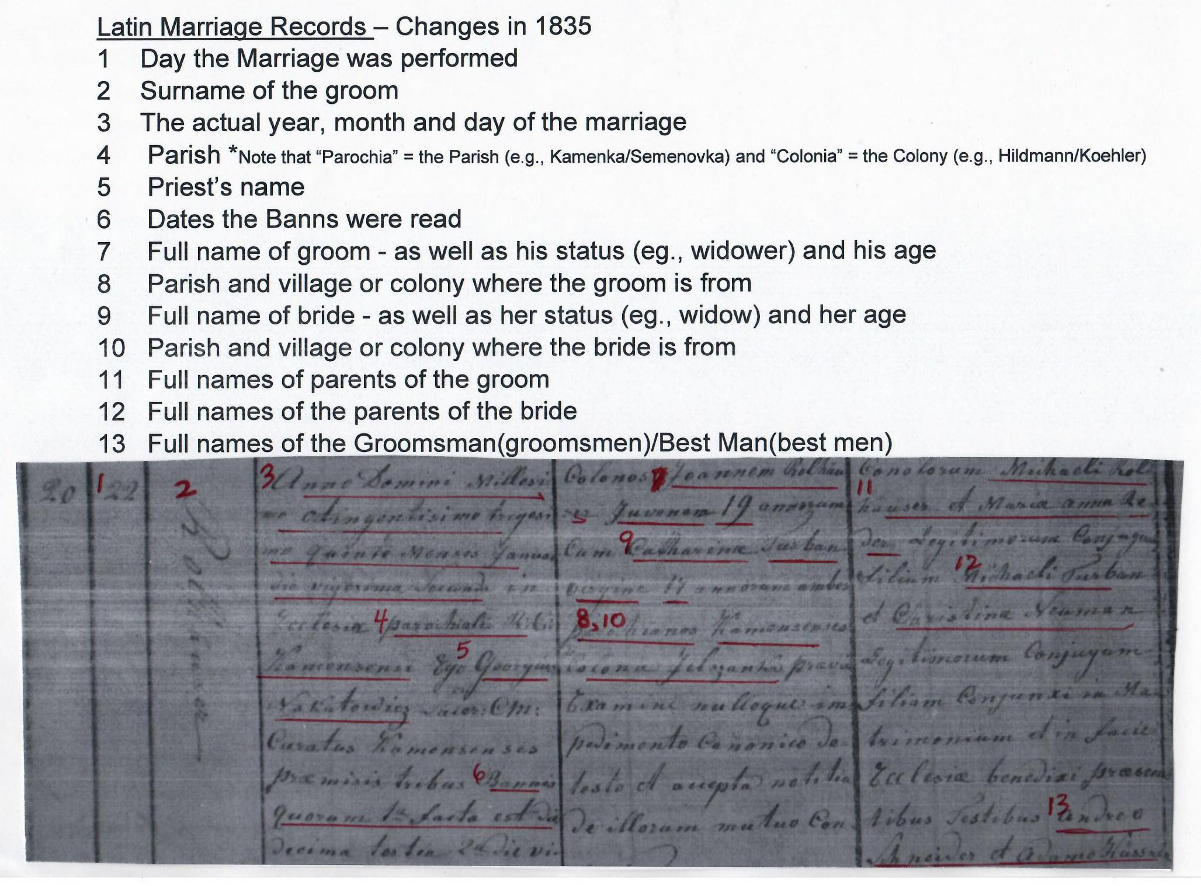
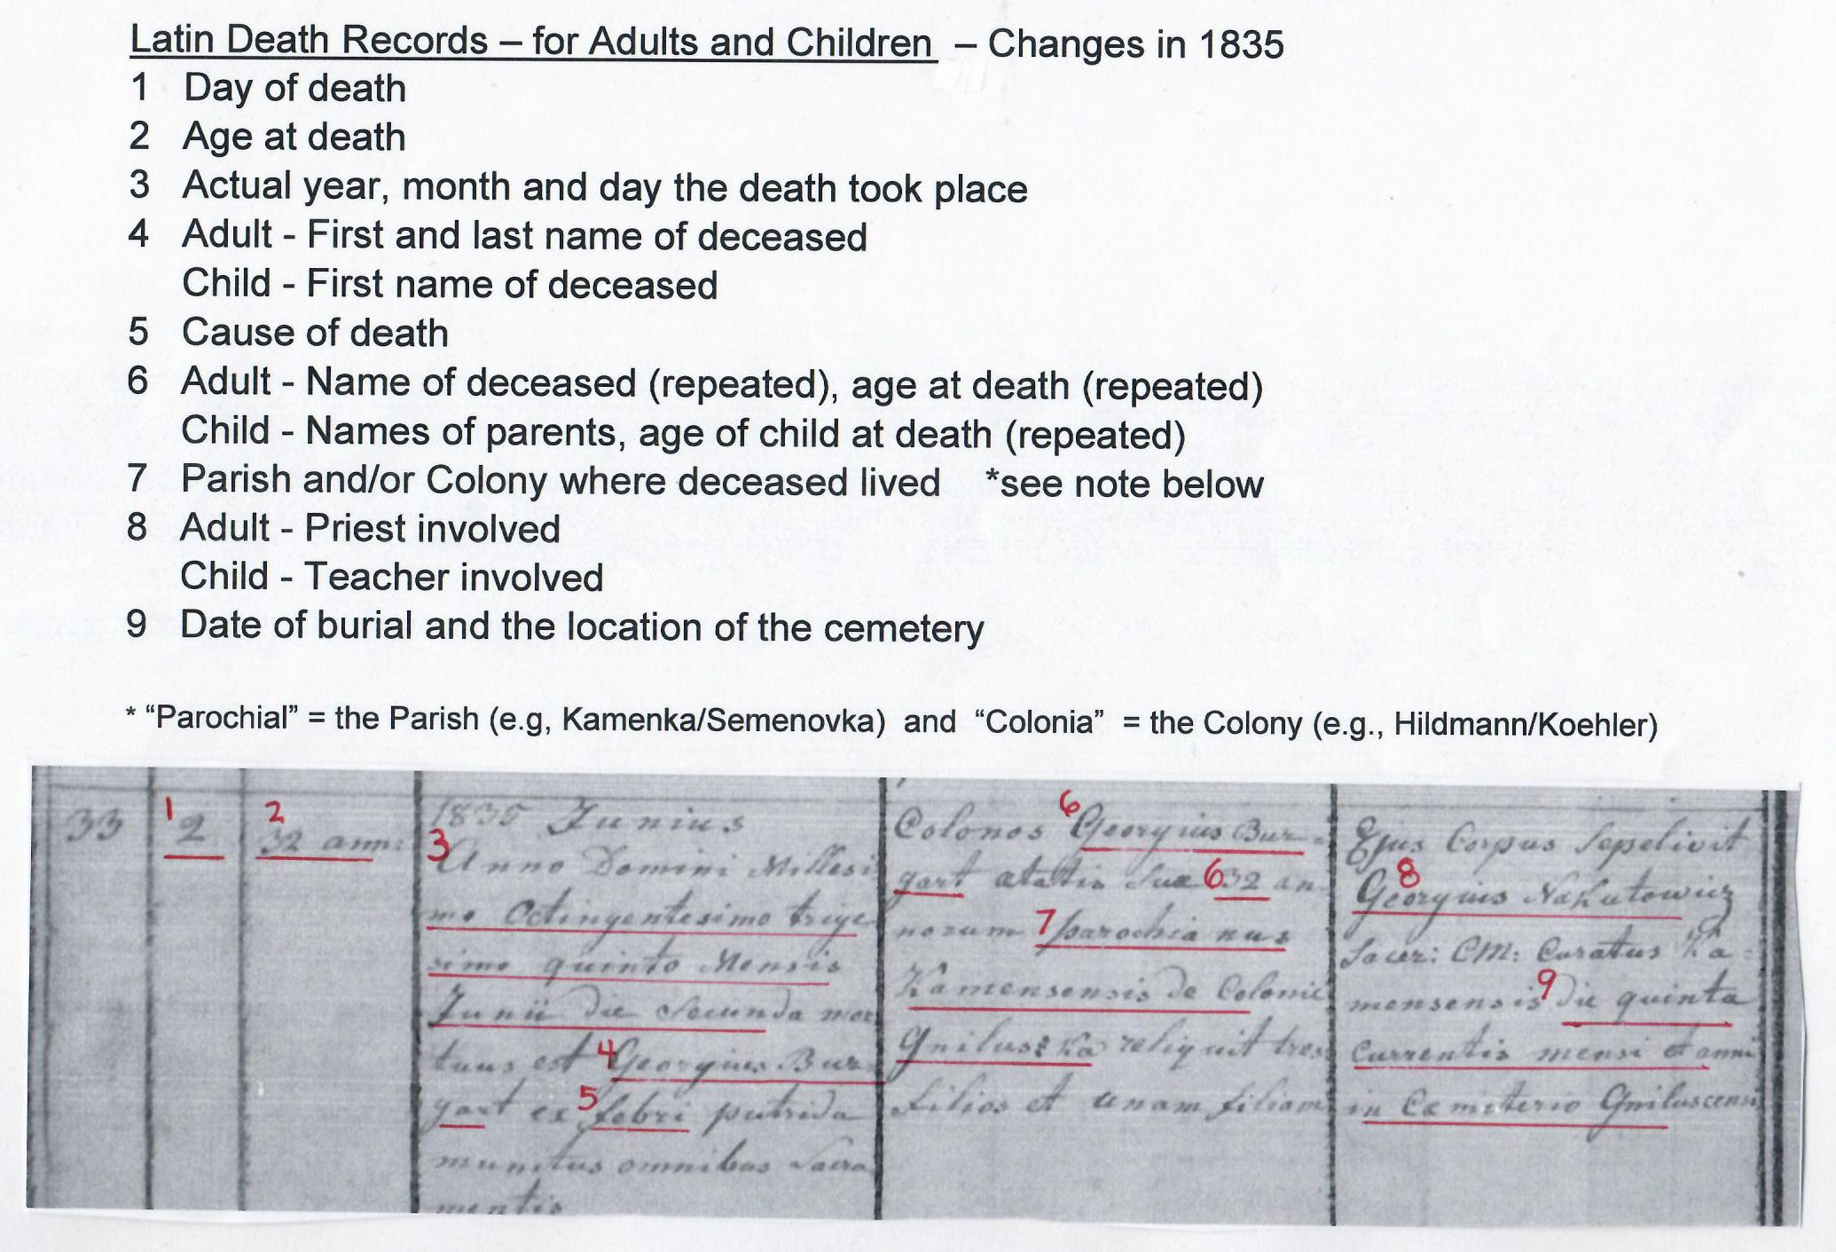
Kamenka Parish Records – Villages Mentioned

Panowka/Panovka = Hildmann
Gniluszka/Gniluschka = Pfeifer
Elshanka/Jelshanka/Eszanka = Husaren
Kaminka/Kamenka = Kamenka
Kopenga/Kopenka = Volmer
Karaulny Buyerak = Köhler
Gryanzavatka = Schuck
Ilavlya = Leichtling

Latin Records – Months, Days (and abbreviations)
Latin Abbreviated | Latin Month | English Month
n/a | Januarius | January
n/a | Februarius | Febuary
n/a | Martius | March
n/a | Aprilis | April
n/a | Maius | May
n/a | Iunius | June
n/a | Iulius or Quintilis | July
n/a | Augustus/Sextilis | August
7bris or ber | September | September
8bris or 8ber | October | October
9bris or 9ber | November | November
10bris or 10 ber | December | December
Latin Day of the Week | English Day of the week
dies Lunae | Monday
dies Martis | Tuesday
dies Mercurii | Wednesday
dies Jovis | Thursday
dies Veneris | Friday
dies Saturni | Saturday
dies Solis | Sunday
Latin Records - Ordinal Numbers

In some genealogical records, numbers (especially dates) are written out.
Written dates may appear with “-a” (feminine ending) or “-um” (neuter ending). In written dates the ordinal numbers can also end with “-o.” eg. Quartus = the fourth Quarto = on the fourth

Decima 10 (also decimus)
Vigesima 20 (also vicesimus) )
Trigesima 30 (also tricesimus)

Prima 1st (also primus)
Seconda 2nd (also secundus)
Tertia 3rd (also tertius)
Quarta 4th (also quartus)
Quinta 5th (also quintas)
Sexta 6th (also sextus)
Septima 7th (also septimus)
Octava 8th (also octavus)
Nona 9th (also nonus)

Examples:
Undecima = 11
Decima Tertia = 12 or Duodecimus
Decima octava = 18
Vigesima quinta = 25
Vigesima quarsta = 24

Latin Birth Records - Terminology

Anni – from
Addendi – Addendum
Cum priore – previous and prior
Dicta – named
Gemini/ Geminus – twin
Gemelae - twins – female; Gemell - male, male and female twin; Gemella – twins
MiJsionis/MiJsioine – Mission
O. P. - Order of Friars (also known as Dominican Friars
Patrini Fuere= Sponsors are
Primus – first (ditto)
S.J. – Society of Jesus
Videua – widow

Latin Marriage Records - Terminology
Ambo - both Ambo ex - both from
Cum uxore - and wife
Duo - both
Duplex - twofold, double, strong
Ex - from Ex Col: - from colony
Geminus - twofold, twin, double, paired, resembling
Idem - the same
Juvenes - young man or young woman Juvenes ambo - both are young
Nomina testium - the name of witnesses
Puella - young woman
Soluti - single, unattached
Tum - then
Uterque - each of two
Utervis - either of two
Viduus - Widow Vidua - Widower
Virgo - damsel
Viduus ambo - both widowed
Virgo – damsel

Latin Death Records - Terminology

A Ludimagistro – teacher
Ab codem – the same
Ad gnam – to fight
Aquo sepultus – from which buried
At as illorum – but as their
Comingata/commendata – recommended by
Defunctorum – dead
Dierum Vita of Seputas – Days and Life of the Buried
In periculum mortis – in danger of death
Ludimagistro - a teacher
Mortuoram – the dead
Munita – protection
Nomen – name
Oibus (omnibus) sacramentis munitus – fortified with all the sacraments
Orbus – bereavement
Ortg – ortus - origin, began, source
Sacramentis munita – fortified by all the last rites
Sine Patrinis – without sponsors
Vita – life Vivus – living

Latin Death Records - Causes of Deaths

Apoplexia – Apoplexy
Artritide/Artritise – Arthritis
Callida febri – [raging] Fever
Debilitate – frail, weak debilias debalitasis debilitate - weakness, infirmity, disable
Fel Fellis Felsi – gall bladder
Hydrope/Hydropisi – Dropsy
Ja Puerperio / e Pueperio – Died in Childbirth
Morbo Stomachi – Disease of the Stomach
Morte subitanea – Sudden death
Pthisis / Pthisi / Thisi– Tuberculosis
Senectute – Old age
Senio – old – old age/senior
Senio confectus – worn out by old age
Paralyti/eus – palsy (paralysis)
Phrenesis/phrenitis – Encephalitis
Submersus – drown?
Tumour prectoris – breast / chest tumour
Tussi/Tussis/Tussio – cough
Ulcere – Ulcers Ulceris Ulcus Ulcero -- wound, ulcer
Una Morte Repentina – death – sudden
Variolis – small pox
Latin Death Records - Age at Death - Days, Weeks, Months

Age at Death

Days Dierum/Diem/Dies = days; Unius die =dies in 1 day
Duo = 2
Tria = 3; Trium dierum = 3 days
5 Vita dierum = 5 days of life

Weeks Hebdom = weeks; Trium hebdom = 3 weeks

Months Mensium = months

Years Anni/Annos = years; Annorum = years of life
1 year Anni unius = 1 year
2 years Annorum duorum = 2 years; Annorum via duorum = 2 years of life
Duos anni terminusis = two year term
3 years Anni Trium = 3 years ; Trium anni = 3 years; Annum tertium = the third year

Latin Fractions and variations
1/2 = dīmidia pars or dīmdium
1/3 = tertia pars
1/4 = quarta par
1/6 = sexta pars
1/8 = octava pars

1/2 year = dīmidia anni or dīmdium anni (6 months)
Dimidii (i) anni = half a year - l/2 annis = ½ year ; In anno ½ = ½ of a year; Unis annicum dimi = one half of one year

1/3 year = anno tertio una (4 months)
Trium anni = one third of a year; Duos saltern extribus per annum = two thirds of a year

1/4 year = Quarto autem anno (3 months)
In anno autum l/4 = ¼ of a year; Unum quartrium anni = one quarter of a year; In anno autem 2/4 = 2/4 of a year; In anno autem ¾ = ¾ of a year; Trium anni – three quarters of a year

1/6 year = qui sex annis (2 months)
1/8 year = unius octo annis (1.5 months)

If you have any questions or comments about the information on this site, please click here or send email to Darryl Boyd
© Darryl Boyd 2020 All rights reserved
No commercial use of these records without express written permission.
Unless otherwise indicated, you may view, download, and print materials from this site only for your personal, noncommercial use only..

